## 1.Introduction

In this experiment we perform two experiments to understand and have thorough knowledge about the conservation of momentum and of energy. Experiment Iillustrate with the measurement of velocities on the basis

of momentum conservation and the Experiment IIdeals with the oblique elastic collisions on an air table.

## 2. Measurement of Velocities on the Basis of Momentum Conservation

The main objective of this experiment is to determine the velocities of the bullets striking the pendulum bob. In order to perform this experiment, the apparatus are setup in such a way that block of Mass *M* was suspended in a long thread of length *l* such that it performs a pendulum motion. The bob is enclosed in a glass box for the safety but to ensure the pendulum motion of the bob, the upper part of the glass box is mounted centrally with adjustable bars to measure the maximum deflection *s*. The gun was adjusted in such a way that the barrel, its tip, is straight to the center of the pendulum bob. To make sure if the barrel was really straight, a calibration bar is inserted into the barrel such that the bullets hit the pendulum bob centrally. Only then a central collision is ensured. The Fig. 1 gives an overall idea about the setup.

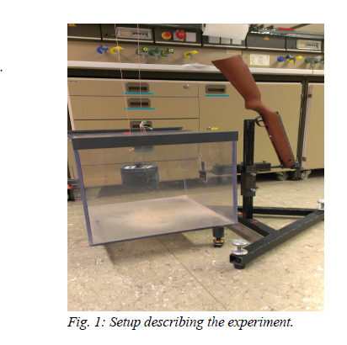

And the theoretical figure and the experimental requirement for this experiment can be illustrated by the figure 2 as below:

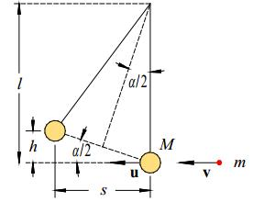

Figure 2 :experiment set up: the red bullet, which has the mass m, has a central collision with the pendulum body of a mass M, after the body gets hit by the bullet with the velocity v the body moves with the velocity u.[1]

By using an air gun (3) to shoot at the pendulum body, which was in a plastic case with just one opening for the gun barrel. After the pendulum body got hit the time is measured over ten time periods.

Furthermore the maximum deflection “s” was measured with a straw that is connected to the end of the plastic case and touched the pendulum body in his idle state.

Than the velocity v is calculated with equation 1 and the error is calculated with equation 2

$v=\frac{M+15m}{m}*\frac{2π}{T}*s$

$∆v_{i}=∆T*\left|\frac{-2*\left(M+15*m\right)*π*s}{m*T^{2}}\right|+∆m*\left|\frac{-2*M*π*s}{m^{2}*T}\right|+∆M*\left|\frac{2*π*s}{m*T}\right|+∆s*\left|\frac{2*\left(M+15*m\right)*π}{m*T}\right|$

With ∆T=0.025s, ∆m=1E-6kg, ∆M=1E-5kg, ∆s=0.001m

With the mass *m*=0.465±0.001g, the mass *M*=1057.951±0.001g

Table 1 measured values from experiment 2

|  |  |
| --- | --- |
| s/m | T/s |
| 0.039 | 2.835 |
| 0.035 | 2.722 |
| 0.036 | 2.787 |
| 0.037 | 2.791 |
| 0.036 | 2.775 |
| 0.035 | 2.809 |
| 0.036 | 2.816 |
| 0.035 | 2.809 |
| 0.036 | 2.800 |
| 0.034 | 2.825 |
| 0.037 | 2.809 |
| 0.036 | 2.763 |
| 0.036 | 2.813 |
| 0.035 | 2.775 |
| 0.035 | 2.797 |

Then vi is plotted over i (shot number) with error bars, also the mean v and the standard deviation are included in the diagram as lines, the result can be seen in figure 2.

The mean of v was 184.64953 and the standard deviation was 5.81066.

After that the velocity u after the collision is calculated with equation 3, the error is given by equation 4.

The kinetic energy before the collision is given by equation 5 the error is given by equation 7, the kinetic energy after the collision is given by equation 6 and the error is given by equation 8.

1. $u=\frac{2π}{T}*s=0.0806\frac{m}{s}$ with T=2.79507±0.00728s and s=0.03587±3.06542E-4m
$u_{error}=∆T*\left|-s*\frac{2π}{T^{2}}\right|+∆s*\left|\frac{2π}{T}\right|=0.0009\frac{m}{s}$

$E_{kin before}=\frac{1}{2}*m*v^{2}=7.927J$

$E_{kin after}\frac{1}{2}*\left(M+m\right)*u^{2}=0.003440J$

${Error}_{Ekin before}=∆v*\left|m*v\right|+∆m*\left|0.5v^{2}\right|=0.146J$

${Error}_{Ekin after}=∆M*\left|0.5*u^{2}\right|+∆m*\left|0.5*u^{2}\right|+∆u*\left|u*\left(m+M\right)\right|=0.000008*J$

2. ${Ekin}_{before}={Ekin}_{after}+D=7.927J=0.003440J+D$ with D= friction and transformation energy

As we can see almost all the energy is transformed in deformation energy and friction, hence we can say that the collision is a perfect inelastic collision (Question 3).

We have only small errors for the kinetic energy, while we can say that the value after the collision is more accurate than the value before the collision.

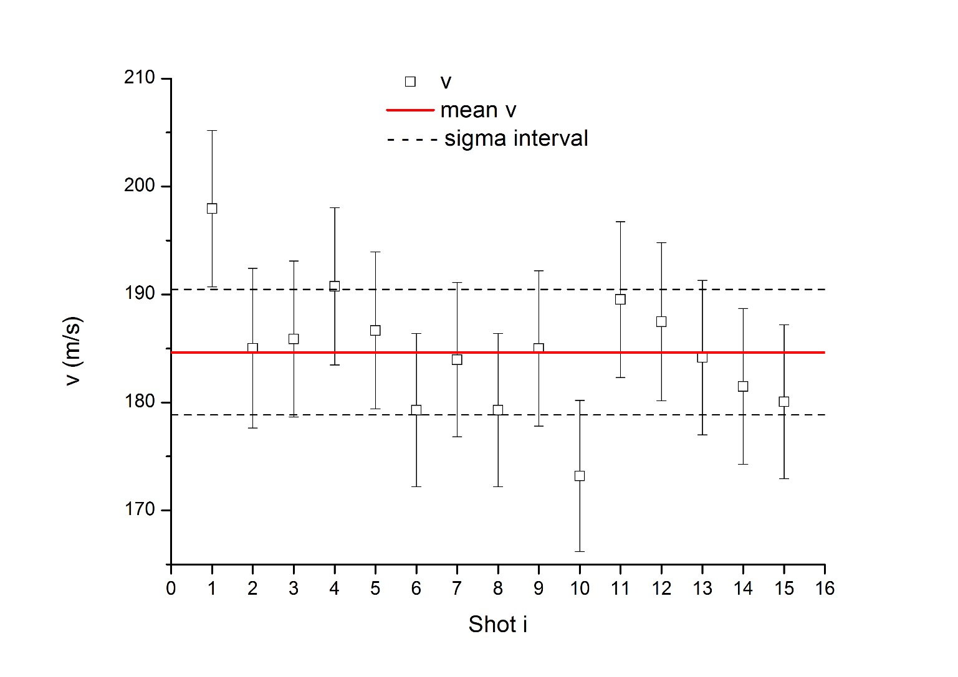

Figure 2 v over i with error bars, the mean and the standard deviation as lines

As we can see in figure 2 we got good results for the velocity v of the bullets. Only 2 values are wide outside the sigma interval. The big error bar can be explained, since the time measurement was done with a stop watch, which results in a big error for the time measurement. Furthermore was the measurement method for s not perfect therefore we have a relative big standard deviation of the mean value for s.

## 3. Oblique elastic collisions on an air table

We observed non-contacting elastic collisions between two pucks, and find out if momentum conservation and energy conservation are valid. The non-contacting collision is due to the repulsion between the magnetic fields of both the picks moving on the air table. The air table is used to create a nearly frictionless surface, which is a condition for elastic collision. The pucks of two different masses are made to collide on the air table, and an image of the collision is taken. In order to make the paths of the pucks clearly distinguishable, a stroboscope is used. So, the instances when the pucks are seen in the image, are when the stroboscope is lit. Once, the image of collision is taken, it is equalized using MatLab, following the instructions given in the Lab script[2]. The equalized image that is received for the experiment is shown in figure 3 below:

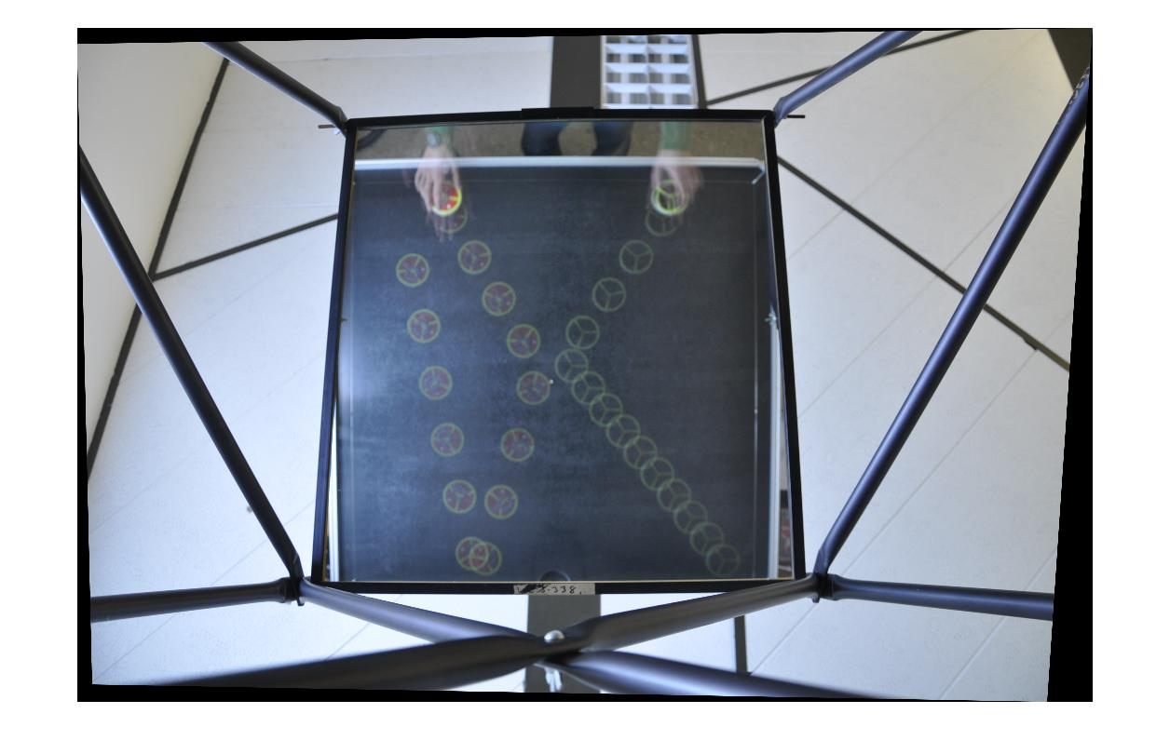

Figure 3: Image showing the paths of the two pucks (red with greater mass) before and after collision

In this experiment the puck with the greatest mass, which is the red puck is referred to as ‘puck 1’, while the blue puck is referred to as ‘puck 2’.The information about the pucks and the stroboscope frequency is shown below:

* Mass of puck 1: *m1 =* (226.44±0.01) g
* Mass of puck 2: *m2 =* (214.74±0.01) g
* Frequency of stroboscope: *f* = 5 Hz

The time period between two consecutive positions of the pucks in Figure 3, is the time period between the two flashes of the stroboscope. So,

The time period $T=\frac{1}{f}=\frac{1}{5 Hz}\sim 0.2 s$

Since, the image in figure 1 has the units of position in pixels (px), it cannot be used to determine the velocity and the momentum of the pucks. Hence, first the magnification *M* of the image is found using the relation:

$$M=\frac{image size}{object size}$$

In order to find the *M*, the diameter of the puck is used. For puck 1, the diameter using the Vernier Caliper is:

$$d=\left(89.90±0.05\right) mm$$

$$=\left(0.08990±0.00005\right) m$$

The image size can be found by determining the diameter of puck 1 from the image in Figure 3. For that the coordinates of the end points are determined using Microsoft Paint, and then the distance between those points were calculated. In this case the two points were: (497 px, 263 px) and (523 px, 289 px). So, the diameter is then:

$$\sqrt{{\left(523-497\right)}^{2}+{\left(289-263\right)}^{2}}=36.769 px$$

So, $$M=\frac{36.769 px}{0.08990 m}$$

$$=408.78 {pxm}^{-1}$$

Now, using the values for *T, M, m1, m2,* a MatLab script is written (see Appendix for all the details about the MatLab code). The readings from two consecutive positions of the puck, before and after the collision, for both the pucks are taken. The results from the MatLab are:

For Puck 1:

Momentum before collision $p_{1}=\left(\begin{matrix}0.0720 \\ 0.1246\end{matrix}\right) {kgms}^{-1}$

Momentum after collision $p_{1}^{'}=\left(\begin{matrix}-0.0499 \\ 0.1690\end{matrix}\right) {kgms}^{-1}$

For Puck 2:

Momentum before collision $p_{2}=\left(\begin{matrix}-0.0762 \\ 0.1077\end{matrix}\right) {kgms}^{-1}$

Momentum after collision $p_{2}^{'}=\left(\begin{matrix}0.0473 \\ 0.0604\end{matrix}\right) {kgms}^{-1}$

For, elastic collision, the total momentum before and after the collision has to be the same, the change in momentum is from MatLab:

$$∆p=\left(\begin{matrix}-0.0016 \\ 0.0030\end{matrix}\right) {kgms}^{-1}$$

The magnitude of change in momentum is:

$$∆p=\sqrt{{0.0016}^{2}+{0.0030}^{2}} {kgms}^{-1}$$

$$=0.0034 {kgms}^{-1}$$

The change in momentum is not exactly 0, as it is theoretically expected. However, it can be assumed to be 0, due to the really small magnitude of $∆p$.

The error for the momentum can be estimated from the error for mass and error for the velocity. The error for velocity can in turn be estimated from the error while measuring the distance from the pixels. Each pixels had measurement error of ±1 px. The distance is measured between two pixels. So, the error for distance would be ±2 px. Since, the time period was taken from the frequency of the stroboscope, it can be considered to be an error free quantity. Hence the error in velocity would be similar as the error in the distance.

Error in distance (*∆x*) =±2 px= $\frac{2 px}{408.78 {pxm}^{-1}}=0.0049 m$

Error in velocity $∆v=\frac{∂v}{∂t}×∆x=\frac{∆x}{t}=\frac{0.0049 m}{0.2 s}=0.024 {ms}^{-1}$

Max. Error in momentum $∆p=∆m×∆v=0.00001kg×0.024 {ms}^{-1}$

$$=2.4×{10}^{-7}kgms^{-1}$$

Hence, the maximum error for momentum is extremely small in this case.

The momentum vectors can be illustrated using a vector diagram as well which is shown in figure 4 below:

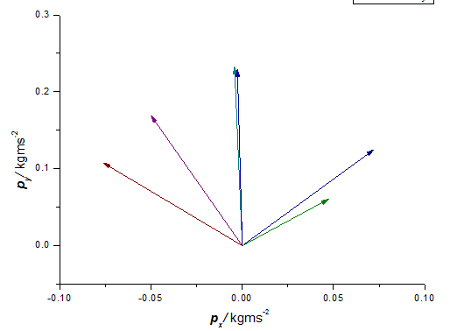

Figure 4: The momentum vectors for both the pucks before and after the collision as well as the momentum vector for the total momentum before and after the collision

The conservation of momentum is also proved by the vector diagram in figure 4 as it also shows that both the initial and the final momentums have nearly equal magnitude and are nearly superimposed over each other.

This elastic collision should follow the energy conservation which says that the kinetic energy before and after the collision should be used. Again MatLab is used to determine the kinetic energy for both the pucks before and after the collision:

For Puck 1:

Kinetic Energy before collision ${KE}_{1}=0.0458 J$

Kinetic Energy after collision ${KE}_{1}^{'}=0.0685 J$

For Puck 2:

Kinetic Energy before collision ${KE}_{2}=0.0405 J$

Kinetic Energy after collision ${KE}_{2}^{'}=0.0137 J$

$$KE={KE}_{1}+{KE}_{2}$$

$$KE^{'}={KE}_{1}^{'}+{KE}_{2}^{'}$$

Change in Kinetic energy $∆KE=KE^{'}-KE=\left({KE}_{1}^{'}+{KE}_{2}^{'}\right)-({KE}_{1}+{KE}_{2})$

$$=0.0685 J+0.0137 J-0.0458 J-0.0405 J$$

$$=-0.0041$$

Our calculation shows a very small decrease in Kinetic energy, just like it is shown for the momentum. The small value of $∆p$ and $∆KE$ could be due to the error in measurement of mass, or even due to the fact that we could not precisely determine the screen coordinates while determining the position vector for the pucks before and after the collision. While performing the experiment, people who also performed this experiment before us had somehow altered the level of the table, due to which accurate results might not be expected. So, that could also be the reason behind the small deviation that is seen. The reason the Kinetic energy conservation is not fulfilled completely could be because the air tables do not create a perfectly frictionless surface. So, it was not completely the ideal case, where energy conservation would have been valid.

## 4. Conclusion

In this way, we can measure the velocities on the basis of Momentum as from the first experiment. So, we can conclude that the collision is an inelastic and

from the energy difference we can see that a lot of mechanical energy is lost due to the friction between the bullet and the sand in the bob. And for the second part of experiment , we have to take care of various things in the experiment to achieve the goal of the this experiment for observing the conservation of momentum and energy of a elastic collision. Since the setup for this experiment is complicated and sensitive, before starting the experiment the air table was adjusted by the technical assistance such that the pucks are not accelerated within the measurement range. The air table on which the special pucks can easily be moved frictionless, we have investigated the oblique total elastic collision of following magnetic pucks for the case *m1* ≠ *m2*, *v1 ≠* 0, *v*2 *≠* 0. Technically, both the experiments are based on the concept of momentum conservation. In the second experiment we had learnt the usage of a stroboscope lamp and a digital camera, also we had to use a new matLab tool named GPRTools to work with the picture

## 6. Appendix

%This script is for the evaluation of the air table elastic collision

%experiment:

clear

close('all','hidden')

T=0.2; %the time period between two consecutive photos

n=1; %time differnce between the two photos whose coordinates were taken

M=408.78; %magnification of image

m1=0.22644; %mass of the PUCK 1 (red)

m2=0.21474; %mass of the PUCK 2 (blue)

%The coordinates of the puck 1 (red) before and after collision:

x1r=509; %x coordinate of position 1 (PUCK 1, BEFORE COLLISION)

y1r=276; %y coordinate of position 1 (PUCK 1, BEFORE COLLISION)

x2r=535; %x coordinate of position 2 (PUCK 1, BEFORE COLLISION)

y2r=321; %y coordinate of position 2 (PUCK 1, BEFORE COLLISION)

x3r=555; %x coordinate of position 3 (PUCK 1, AFTER COLLISION)

y3r=478; %y coordinate of position 3 (PUCK 1, AFTER COLLISION)

x4r=537; %x coordinate of position 4 (PUCK 1, AFTER COLLISION)

y4r=539; %y coordinate of position 4 (PUCK 1, AFTER COLLISION)

%The coordinates of the puck 2 (blue) before and after collision:

x1b=683; %x coordinate of position 1 (PUCK 2, BEFORE COLLISION)

y1b=275; %y coordinate of position 1 (PUCK 2, BEFORE COLLISION)

x2b=654; %x coordinate of position 2 (PUCK 2, BEFORE COLLISION)

y2b=316; %y coordinate of position 2 (PUCK 2, BEFORE COLLISION)

x3b=670; %x coordinate of position 3 (PUCK 2, AFTER COLLISION)

y3b=463; %y coordinate of position 3 (PUCK 2, AFTER COLLISION)

x4b=688; %x coordinate of position 4 (PUCK 2, AFTER COLLISION)

y4b=486; %y coordinate of position 4 (PUCK 2, AFTER COLLISION)

%The position vectors for puck 1 (red) before and after collision:

r1r=[x1r;y1r]/M %position vector for position 1 (PUCK 1, BEFORE COLLISION)

r2r=[x2r;y2r]/M %position vector for position 2 (PUCK 1, BEFORE COLLISION)

r3r=[x3r;y3r]/M %position vector for position 3 (PUCK 1, AFTER COLLISION)

r4r=[x4r;y4r]/M %position vector for position 4 (PUCK 1, AFTER COLLISION)

%The position vectors for puck 2 (blue) before and after collision:

r1b=[x1b;y1b]/M %position vector for position 1 (PUCK 2, BEFORE COLLISION)

r2b=[x2b;y2b]/M %position vector for position 2 (PUCK 2, BEFORE COLLISION)

r3b=[x3b;y3b]/M %position vector for position 3 (PUCK 2, AFTER COLLISION)

r4b=[x4b;y4b]/M %position vector for position 4 (PUCK 2, AFTER COLLISION)

%The momentum of puck 1 (red) before and afer collision:

pr=m1*(r2r-r1r)/(n*T) %momentum vector (PUCK 1, BEFORE COLLISION)

prs=m1*(r4r-r3r)/(n*T) %momentum vector (PUCK 1, AFTER COLLISION)

%The momentum of puck 2 (blue) before and afer collision:

pb=m2*(r2b-r1b)/(n*T) %momentum vector (PUCK 2, BEFORE COLLISION)

pbs=m2*(r4b-r3b)/(n*T) %momentum vector (PUCK 2, AFTER COLLISION)

%Sum of the momentum before and after collision and to check if change in

%momentum is 0:

p=pb+pr %momentum before collision

ps=pbs+prs %momentum after collision

delta_p=p-ps %change in momentum

%The K.E. of puck 1 (red) before and after collision:

er=(1/2)*m1*(norm((r2r-r1r)/(n*T)))^2 %Kinetic energy (PUCK 1, BEFORE COLLISION)

ers=(1/2)*m1*(norm((r4r-r3r)/(n*T)))^2 %Kinetic energy (PUCK 1, AFTER COLLISION)

%The K.E. of puck 2 (blue) before and after collision:

eb=(1/2)*m2*(norm((r2b-r1b)/(n*T)))^2 %Kinetic energy (PUCK 1, BEFORE COLLISION)

ebs=(1/2)*m2*(norm((r4b-r3b)/(n*T)))^2 %Kinetic energy (PUCK 1, AFTER COLLISION)

1. See Pg. 177 Fig. 1 of Reference /1/
2. See page 184 of reference /1/